**Research on mutual dynamic interactions between track and vehicle during the passage of rolling stock through a railway turnout**

Adam Mańka1, Tomasz Albrecht2

1. Silesian University of Technology, Faculty of Transport and Aviation Engineering, Department of Railway Engineering, Gliwice, Poland, [adam.manka@polsl.pl](mailto:adam.manka@polsl.pl)
2. The Track Tec Group – Warsaw, Poland, t.albrecht@tracktec.eu

Received October 2023

**Abstract:** The study of dynamic track-vehicle interactions is often analyzed for a straight track or track in horizontal curve, less often for a train passing through a turnout. Turnouts are a critical element of railway lines. The study will focus particularly on the assessment of various turnout structures in terms of cooperation with a rail vehicle. In railway turnouts, problems related to the quality of maintaining stable geometric properties and the stability of moving elements may affect the safety of rail vehicles. Derailments on turnouts happen much more often than on other sections of track. The research focused on the analysis of dynamic wheel-rail interactions measured from the track level. We asked ourselves question in this research: whether each structure with the same radius and identical homologation up to 250 km/h behaves in the same way under the influence of passing rolling stock?

1. **Introduction**

Currently, research is being carried out in rail transport to increase the level of automation of vehicle and railway infrastructure diagnostics. The constant tendency to increase the speed of means of transport with the need to maintain safety and limited financial resources forces the search for solutions that will allow automatic assessment of the condition of the vehicle and railway infrastructure. One of the most capacious carriers of information about the technical condition of a facility is vibrodiagnostics [16, 23, 24, 26]. There are a number of works in the literature that use vibration measurement on a vehicle [7, 8, 9, 10, 11, 12, 13] to analyze the technical condition of the vehicle and the technical condition and detection of defects in the railway infrastructure [3, 4, 5 , 16, 18, 20, 21, 22]. However, there are few works that practically examine and identify quantities that, based on the measurement of vibrations and displacements of railway turnout elements, will allow for the diagnosis of this element, taking into account the variability of excitations depending on the type, driving parameters, technical condition and defects of railway vehicles [6 , 14, 15, 17, 25].

The research we initiated had one goal, to assess different types of turnout structures and different types of trains in dynamic interactions on high-speed lines. We can often find in the literature the assessment of the interactions between turnouts and rolling stock assessed from the level of sensors installed on the rail vehicle; such observations clearly show the variable stiffness of the turnout as a structure. Below we can see (Figure 1) the acceleration measurements carried out by the assessment body while obtaining the turnout approval. The data concerns accelerations recorded in sensors installed in the elements of the car bogies. The diagram shows the three key elements of a railway turnout (red is the switch, green is the connecting rails, blue is the crossing area). The graph shows varied vertical and lateral accelerations recorded from the sensors. When analyzing the dynamic impacts at the wheel-rail interface, the reason and theory for uneven horizontal impacts in train movement should be described. A parameter characterizing this movement is "equivalent conicity".

The described theory of equivalent conicity is the basis for determining the most realistic description of wheel-rail motion. Equivalent conicity is defined as the actual wheel-rail contact point and is expressed numerically as tanγe (or γe) of the cone angle of a wheel with a conical profile. The measurements should demonstrate in practice the nature of the interactions of the described theory. The nature of the horizontal movement is one of the impacts, the other main component are the vertical impacts related to the mass of the train, its speed and the quality of the track. In our opinion, the assessment of turnouts and rolling stock solely based on the level of sensors installed on the train is not complete and does not give a full picture. So in our research we assessed their mutual work from sensors installed at the turnout. The study will focus on the assessment of individual moving elements and their connections with the entire structure in terms of assessing cooperation with rail vehicles and comparing the operation of various turnout structures in order to distinguish weak and good types of structures.

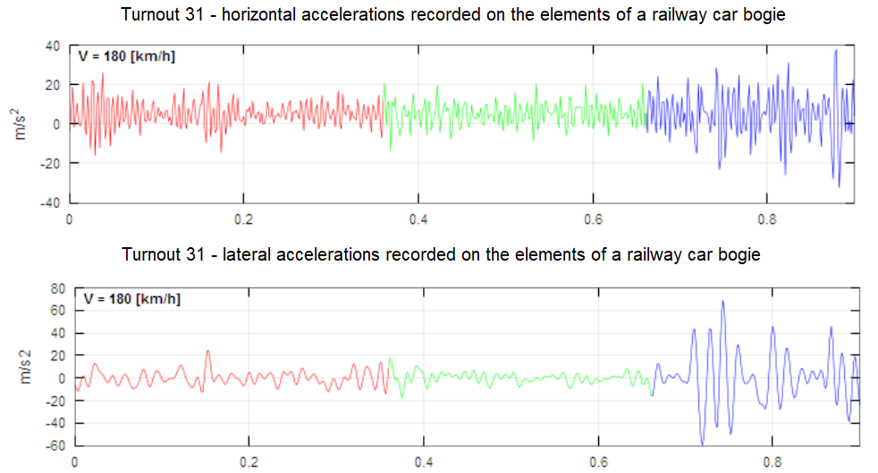

Fig. 1.Accelerations recorded in acceleration sensors on car bogie while passing through a turnout

1. **Description of research**

At The article describes the first stage of the research carried out. Based on the experience gained, in this stage of research it was decided to examine the switch area which could potentially pose problems in maintaining the continuity of stiffness and geometric stability during the train's passage i.e. the blades. Turnout's blades are held by locker devices in the front part, while at the brackets distance they are supported by stop inserts by pressing (based on the shape set at the factory). The research compared two turnout designs with the same radius R500 and identical approval allowing trains to operate at speeds of up to 250 km/h. To summarize, the research attempted to investigate the following issues:

1. the ability to maintain the correct geometry and stability of moving elements,
2. gaining knowledge regarding dynamic interactions with a rail vehicle.

The research also analyzed standard methods for verifying the correct operation of a railway turnout. Periodic tests carried out throughout the life cycle of a railway turnout, which are undertaken by the manufacturer's service or persons responsible for infrastructure maintenance employed by the user, are limited to static tests of geometry. Here are examples of measurements used to verify a railway turnout: tests of track gauges and flangeway, tests of distance to touch of blades and opening, length measurements. However, none of the static measurement methods take into account dynamic changes in geometry during the passage of a rail vehicle. For many years, it has been assumed incorrectly that such influence does not relevant effects on clearances and other measured elements. The main assumptions of the dynamic tests carried out (stage 1) were: examination of selected spaces and turnout elements in terms of displacements and accelerations. Figure 2 below shows the area examined. As mentioned earlier, this is a place where the blades do not have locker devices (the blade is supported only by brackets). Through the research we want to find out how unfavorable the impacts are and whether all turnout structures are equally safe.

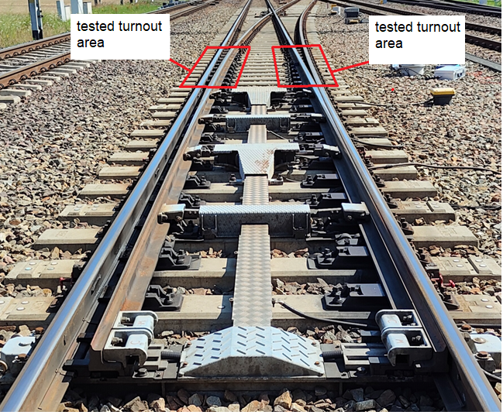Fig. 2.The turnout with a highlighted research area (in the photo we can see the switch area and elements such as point machine, actuators and detection devices)

* 1. **Methods analysis**

This part will briefly describe the research methods and the sensors and devices used in the research. Due to the lack of space and the complicated shapes of the rails, it was necessary to design and manufacture devices that would stably mount the sensors, in particular a digital clock sensor that was responsible for the measurement of the blades displacements. The displacement sensor was attached to the blade rail so that the measuring needle was pre-tensioned to the stock rail foot (figure 3). The designed system made it possible to assess mutual displacements of the distance between the rigidly built-in stock rail and the blade.

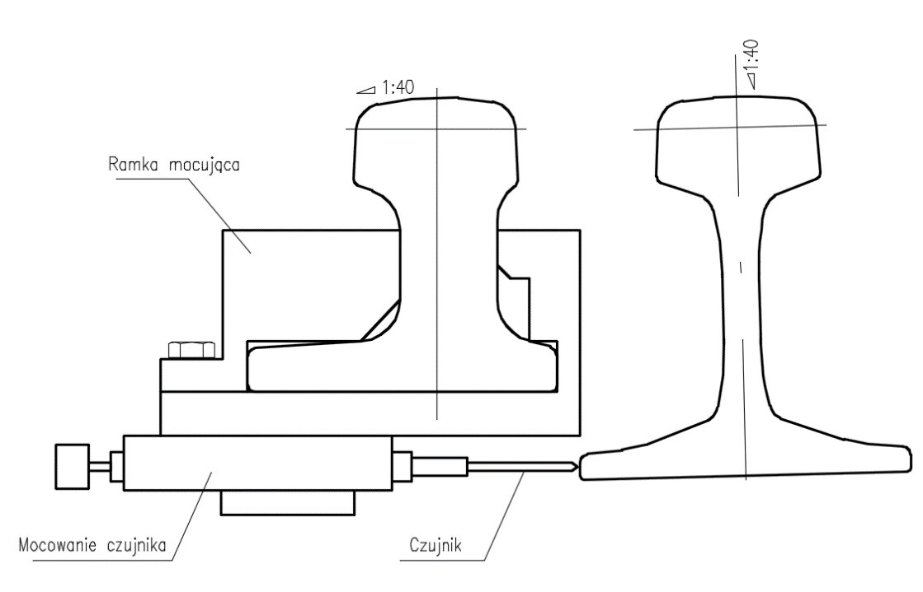

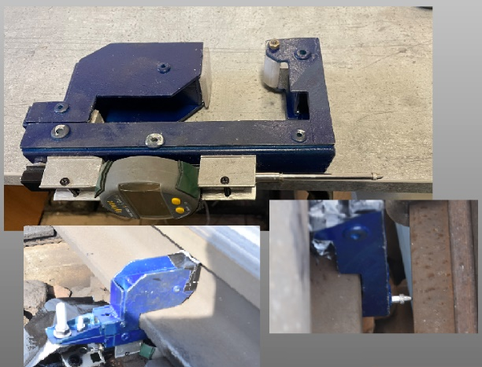Fig. 3.Measurement of blades displacements during the passage of rolling stock by using a digital dial sensor

Additionally, during the initial period of research, the movements were observed by a camera. A the measure was placed in the observed place to observe movements during the train's passage. From the bottom, the whole thing was recorded by a camera with an appropriate frame rate. The purpose of the observation was to correctly select the range of the dial sensor.

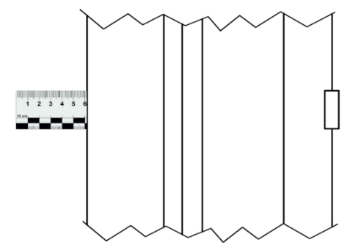

Fig. 4. The measuring tape for observing displacements through a camera

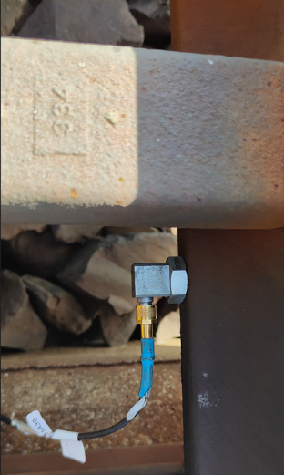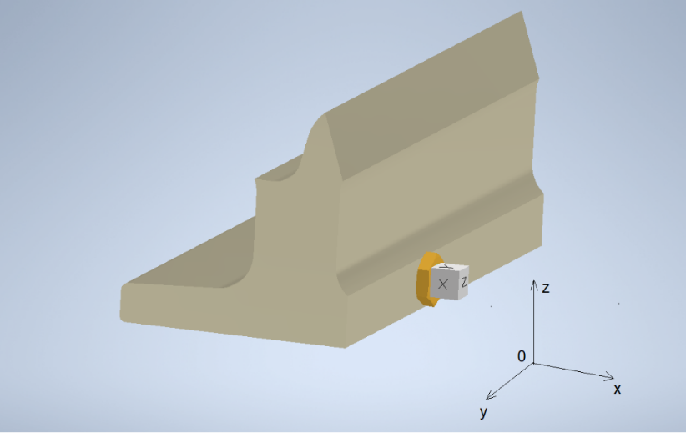The accelerations were measured on the blades foot in the discussed area of the railway switch. When analyzing accelerations and vibrations, we deal with the waveforms of natural and forced vibrations of mechanical systems (infrastructure and rail vehicle). For simple systems, these waveforms can be determined analytically. For such complex systems as the interaction of a vehicle with infrastructure (wheel-rail), these waveforms are the result of the superposition of natural vibrations and the most effective method is the actual measurement of mutual interactions. We evaluate accelerations by the instantaneous acceleration vector a. We determine this vector by measuring its coordinates: ax, ay, az. The acceleration is proportional to the force acting. The measurements used three-axis piezoelectric sensors considered to be basic for diagnostic applications. Acceleration sensors were attached to the blade foot using magnets. The Dewesoft software was used to process the signals. Dewesoft is a leading provider of data acquisition (DAQ) systems and signal processing solutions. Data acquisition and analysis software Dewesoft is used among research and development leaders in Automotive, Aerospace, Defense, Transportation, Power, Industrial, and other industries.

Fig. 5. Sensor installation method and reference to the actual projection of the coordinate system

* 1. **Tested railway turnout structures**

The tests were carried out at two railway turnouts at the Psary Station on the CMK railway line. Both turnouts are located on the main tracks of the mentioned line. The CMK line is one of the high-speed lines in Poland. The railway line is managed by the National User, PKP PLK. The tables below (tables no 1 and 2) present the technical specifications of both turnouts along with a description of the installed devices responsible for switching and detection.

Type of tested turnouts and technical details:

|  |  |  |
| --- | --- | --- |
| Type of tested turnouts: 60E1-500-1:12  Turnout no. 31 in Psary Station, description of the structure:  Table no 1 | |  |
| Point machine specification | |
| Type of point machine | Hy-Drive (Alstom) with hydraulik backdrive |
| Quantity of switching points | Three switching points |
| Rods | Two extra rods |
| Switch rolls system | Switch rolls system with holding funktion (blades holding) |

|  |  |  |
| --- | --- | --- |
| Type of tested turnouts: 60E1-500-1:12  Turnout no. 5 in Psary Station, description of the structure:  Table no 2 | |  |
| Point machine specification | |
| Type of point machine | Bombardier EEA5 (two point machine) |
| Quantity of switching points | Two switching points |
| Rods | Without extra rods |
| Switch rolls system | Switch rolls system without holding funktion (blades holding) |

1. **Results of research on mutual interactions between turnout and rail vehicle**

The measurements analyzed the interactions between the rail vehicle and the turnout (wheel-rail contact). We managed to capture about a dozen measurements at each turnout. Various types of trains and wagons took part in the journey. For the article below, journeys of the same type of train at similar speeds were taken into account. It is worth mentioning that the travel speeds were not very high, due to restrictions related to renovation works at nearby stations. Measurements in the next stages will be updated to include trips at higher speeds.

* 1. **Measurement results from the blade displacement sensor**

The analysis of the displacement sensor results gives clear results and allows to describe different characteristics of the behavior of the blades in both turnouts. In all measurements turnout direction was set in straight ahead. The table below (Table No. 3) shows the highlighted results. The selection of results resulted solely from an attempt to collect measurements of similar speed and the same type of train (Pendolino train type). The stiffer structure of the switch frame in turnout 31 and the use of special rollers with the function of holding the blades make the blades significantly less susceptible to deflection. The maximum deviation from the base position was 0.382 mm. Then, measurements were taken at turnout No. 5. The displacements recorded in the older type structure (however, this system is still the most frequently used construction configuration in turnouts with a radius of R500 in Europe) were clearly larger.

The maximum deviation from the base position was 2.513 mm. Comparing the results of both turnouts gives almost 7 times greater impact at the older type of structure. Taking into account the mechanism occurring during the train's passage, this means continuous elastic deflection of the rails and their attack by the approaching wheels. Of course, the level of increased wear is difficult to analyze in such short studies, but the conclusions regarding the increased wear of rails and wheels in older structures turnout are obvious.

|  |  |  |  |  |  |  |  |
| --- | --- | --- | --- | --- | --- | --- | --- |
| Table no 3. Comparison of measurement and calculation results for turnouts No. 5 and 31 | | | | | | | |
| Turnout No | Measurement No | Speed [km/h] | The value for the static position was assumed to be the initial value [mm] | Verage value  [mm] | Standard deviation  [mm] | Maximum deviation from the static value (line/ -) | Maximum deviation from the static value (line/ +) |
| 31 | 1 | 100 | 13,607 | 13,685 | 0,13 | -0,358 | 0,202 |
| 2 | 98 | 13,845 | 13,793 | 0,147 | -0,382 | 0,239 |
| 5 | 16 | 103 | 14,71 | 13,676 | 0,811 | -2,513 | 0,285 |
| 17 | 105 | 14,362 | 14,078 | 0,735 | -2,123 | 1,865 |

The differences in the results of the observed displacements in two different types of turnouts are very clearly shown by the Chart (Figure 6).

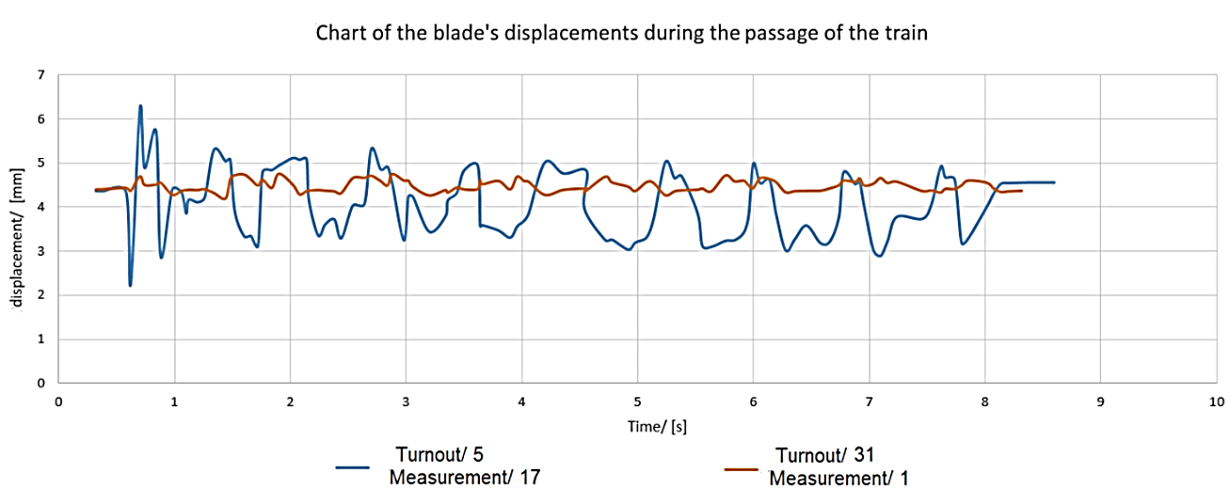

Fig. 6. Comparison of blades displacements at turnouts No. 5 and 31 when trains run at the same speed

* 1. **Measurements of accelerations recorded on the blades**

The assumption of the first stage of accelerations research was to observe the interactions between the rail vehicle and the turnout and to correlate the values of the measured displacements and accelerations. Acceleration charts allowed for the observation of the interactions caused by subsequent wheel sets and wagon bogies. Each subsequent run of the wheelset was shown on the graph as a reading of subsequent acceleration peaks. In the table below, we can observe the maximum recorded accelerations for the four highlighted measurements (already discussed earlier). The large discrepancy in the results is noteworthy. It was decided to thoroughly analyze measurement numbers 1 and 2 in order to explain the large differences in the recorded accelerations (both recorded measurements took place at the same turnout, at a similar speed and the same type of train).

A detailed analysis of accelerations showed that most of the recorded accelerations during the trip were similar, and the result was influenced by two distinct acceleration peaks which were the result of the passage of two trolleys with a clearly different operating condition. At this stage, periods of increased displacements and acceleration peaks were clearly visible - based on the observations, the passage of the wheel could be detected very precisely.

|  |  |  |  |  |  |  |  |  |  |  |
| --- | --- | --- | --- | --- | --- | --- | --- | --- | --- | --- |
| Table no 4. Acceleration measurements carried out by installed accelerometers | | | | | | | | | | |
| Turnout No | Measurement No | Acceleration value on the X axis  [m/s2] | | | Acceleration value on the Y axis  [m/s2] | | | Acceleration value on the Z axis  [m/s2] | | |
|  |  | w (+) | w (-) | amp-litude | w (+) | w (-) | amp-litude | w (+) | w (-) | amp-litude |
| 31 | 1 | 1334,8 | -1434,8 | 2769,6 | 528,1 | -570,6 | 1098,7 | 783,8 | -635,6 | 1419,4 |
| 2 | 175,6 | -255,8 | 431,4 | 288,2 | -132,5 | 420,7 | 615,7 | -293,8 | 909,5 |
| 5 | 16 | 282,0 | -258,0 | 540 | 228,7 | -299,5 | 528,2 | 540,5 | -557,5 | 1098 |
| 17 | 742,1 | -447,6 | 1168,7 | 1794,4 | -1857,4 | 3651,8 | 1106,2 | -1875,5 | 2981,7 |

In the chart below (figure 7) we can see the result of the passage of the two trains discussed above. It is clearly visible that in run no. 2 all passing wheels give similar results, while in run no. 1 two sets of wheels gave clearly different results (that is why the graph was scaled).

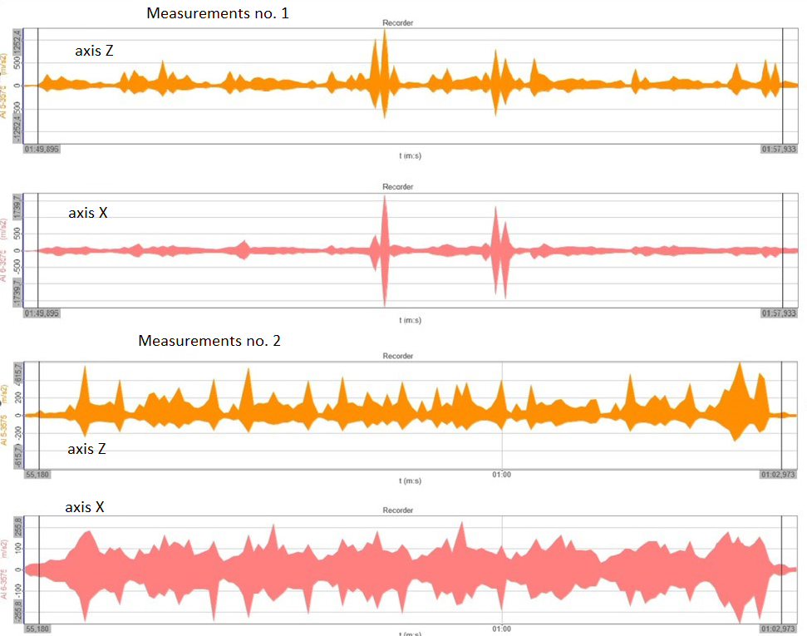

Fig. 7. Comparison of measurements no. 1 and 2 on the Z and X axes for the same speed and type of Pendolino train

1. **Conclusions**

The research allowed to observe the behavior of critical points of the turnout in interaction with rail vehicles. The study observed defects and problems related to maintaining the continuity of the turnout point geometry during the passage of the train. Mutual wheel-rail interactions, with improper construction of turnouts and high speed of the rolling stock, can cause local wear of the rail heads and consequently, deviations from the geometry planned by the designer and unstable train running. The summary included in the points below will also be an attempt to answer the theses and questions posed at the beginning of the article regarding the possibility of assessing the quality of switches and problems resulting from wheel-rail interactions based on the measurements carried out.:

1. Observations made using a sensor of the displacement of the blades and their mutual interactions show differences in the operation of turnouts of different types of construction and their technological advancement. It is clearly visible that new, more refined turnout designs holds better the correct geometry in critical points of switches. For the user, this is a signal that it is advisable to invest in more modern structures for the needs of high-speed lines.

2. The measurements also made it possible to observe the behavior of rail vehicles, providing the potential for diagnostics of the condition of bogie and wheel elements - in this case, the measurements made with acceleration sensors were decisive. The results of accelerations of the observed journeys showed that some assemblies of wagon and train chassis components show clearly increased impact on the track, the conclusion should be interpreted as probable problems with the quality of rolling stock maintenance.

3. The first stage of the research showed that the research has great potential in the diagnosis of both railway turnout areas and rail vehicles passing over them. Selected observation techniques gave many interesting results, although not always expected. Taking into account the obtained results, the research will be extended to include observations of other critical elements in order to understand specific impacts that have a significant impact on traffic rail safety.

**References**

1. Bałuch H., Diagnostyka nawierzchni kolejowej, Wydawnictwa Komunikacji i Łączności, Warszawa, 1978;
2. K. Knothe, R. Wille, and B.W. Zastrau. Advanced contact mechanics: Road and rail. Vehicle System Dynamics, 35(4-5):361–407, 2001;
3. G. Bakyt, S. Abdullayev, N. Suleyeva, A. Yelshibekov, Z. Seidemetova, Z. Sadvakassova: Research on mutual dynamic interactions between track and vehicle during the passage of rolling stock through a railway turnout, ; Transport Problems, 2020 Volume 15 Issue 2, 2020r;
4. B. Saura, A. Gonzalez, V. Gonzalez, J. Luis & Ribes, F. & Real-Herráiz, Julia. (2018). Study of the dynamic vehicle-track interaction in a railway turnout. Multibody System Dynamics. 43. 1-16. 10.1007/s11044-017-9579-2;
5. Celiński, I., Burdzik, R., Młyńczak, J., & Kłaczyński, M. (2022). Research on the applicability of vibration signals for real-time train and track condition monitoring. Sensors, 22, 1–19. https://doi.org/10.3390/s22062368
6. Burdzik, R.; Słowiński, P.; Juzek, M.; Nowak, B.; Rozmus, J. Dependence of damage to the running surface of the railway rail on the vibroacoustic signal of a passing passenger train. Vibroengineering Procedia 2018, 19, 226–229.
7. Li, C.; Luo, S.; Cole, C.; Spiryagin, M. An overview: Modern techniques for railway vehicle on-board health monitoring systems. Veh. Syst. Dyn. 2017, 55, 1045–1070
8. Goodall, R. M., & Roberts, C. (2006). Concepts and Techniques For Railway Condition Monitoring. In IET International Conference on Railway Condition Monitoring (11575 ed., pp. 90-95). IET. https://doi.org/10.1049/ic:20060050
9. Hitoshi Tsunashima: Railway Condition Monitoring, Present and Application for Regional Railways. Report of the Research Institute of Industrial Technology, Nihon University, N.102, 2018, ISSN 0386-1678
10. Robert Lagnebäck. Evaluation of wayside condition monitoring technologies for condition-based maintenance of railway vehicles, Luleå University of Technology, 2007
11. R. W. Ngigi, C. Pislaru, A. Ball, F. Gu: Modern techniques for condition monitoring of railway vehicle dynamics, Journal of Physics: Conference Series, Volume 364, 25th International Congress on Condition Monitoring and Diagnostic Engineering (COMADEM 2012) 18–20 June 2012, Huddersfield, UK, Conf. Ser. 364 012016
12. Cheng, C.; Wang, J.; Chen, H.; Chen, Z.; Luo, H.; Xie, P. A Review of Intelligent Fault Diagnosis for HighSpeed Trains: Qualitative Approaches. Entropy 2021, 23, 1. <https://dx.doi.org/> 10.339/e23010001
13. Yi C, Wang D, Fan W, Tsui K-L, Lin J. EEMD-Based Steady-State Indexes and Their Applications to Condition Monitoring and Fault Diagnosis of Railway Axle Bearings. Sensors. 2018; 18(3):704. <https://doi.org/10.3390/s18030704>
14. Ward, Christopher P., Roger M. Goodall, and Roger Dixon. 2019. “Creep Force Estimation at the Wheel-rail Interface”.https://hdl.handle.net/2134/8769.
15. Tsunashima, Hitoshi & Matsumoto, Akira & Mizuma, Takeshi & Mori, Hirotaka & Naganuma, Yasukuni. (2012). Condition Monitoring of Railway Track Using In-Service Vehicle. 10.1299/jmtl.3.154.
16. T. Kojima, H. Tsunashima & A. Matsumoto: Fault Detection Of Railway Track By Multi-resolution Analysis, WIT Transactions on The Built Environment, Volume 88, Pages 10, Published, 2006, DOI 10.2495/CR060931, WIT Press
17. Barkhordari, P., & Galeazzi, R. (2018). Statistical Model of Railway's Turnout based on Train Induced Vibrations. I F A C Workshop Series, 51(24), 1278-1284. DOI: 10.1016/j.ifacol.2018.09.570
18. Barkhordari, P., Galeazzi, R., Tejada, A. de M., & Santos, I. F. (2017). Low-complexity Behavioral Model for Predictive Maintenance of Railway Turnouts. Annual Conference of the PHM Society, 9(1). https://doi.org/10.36001/phmconf.2017.v9i1.2399
19. Berggren, E. (2009). Railway Track Stiffness - Dynamic Measurements and Evaluation for Efficient Maintenance. Phd thesis, Royal Institute of Technology
20. H.F. Lam, M.T. Wong, Y.B. Yang, A feasibility study on railway ballast damage detection utilizing measured vibration of in situ concrete sleeper, Engineering Structures, Volume 45, 2012, pages 284-298, ISSN 0141-0296,<https://doi.org/10.1016/j.engstruct.2012.06.022>
21. M.A. Boogaard, Z. Li, R.P.B.J. Dollevoet, In situ measurements of the crossing vibrations of a railway turnout, Measurement, Volume 125, 2018, Pages 313-324, ISSN 0263-2241, <https://doi.org/10.1016/j.measurement.2018.04.094>.
22. Kouroussis, G.; Caucheteur, C.; Kinet, D.; Alexandrou, G.; Verlinden, O.; Moeyaert, V. Review of Trackside Monitoring Solutions: From Strain Gages to Optical Fibre Sensors. Sensors 2015, 15, 20115-20139. <https://doi.org/10.3390/s150820115>
23. Seyedahmad Jalili Hassankiadeh: Failure Analysis of Railway Switches and Crossings for the purpose of Preventive Maintenance, Royal Institute of Technology, SE-100 44 Stockholm, TRITA-VBT 11:17, ISSN 1650-867X
24. Kisilowski, J.; Kowalik, R. Railroad Turnout Wear Diagnostics. Sensors 2021, 21, 6697. <https://doi.org/10.3390/s21206697>
25. Kisilowski J.: O pewnych zjawiskach mających wpływ na bezpieczeństwo ruchu pociągu o podwyższonej prędkości, Technika Transportu Szynowego, v. 1139, Instytut Naukowo-Wydawniczy "TTS", 2012 r.
26. R. Müller, B. Faure, E. Bongini, A. Zemp, J. Nielsen, B. Pålsson: Ground vibration from turnouts: numerical and experimental tests for identification of the main influencing sources/factor, International Union of Railways (UIC), pages 51, 31/12/2013.